Today Someone shared the post regarding The 25 Most Failed States on Earth, I wonder what is the position of Nepal, who is the most success on Earth, Who is worst in South Asian Region and many other question.

The Failed States Index is based on the twelve primary social, economic and political indicators of the CAST methodology, developed by The Fund for Peace:

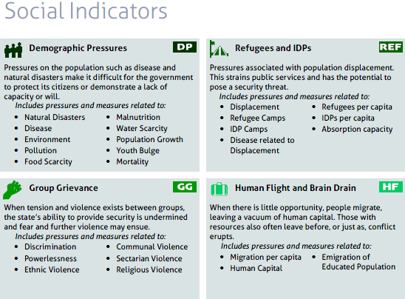
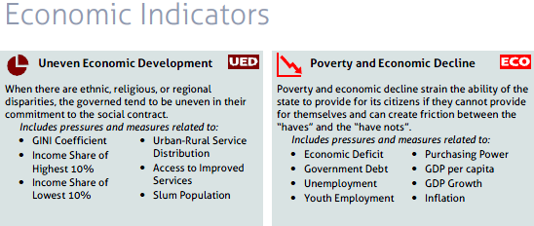

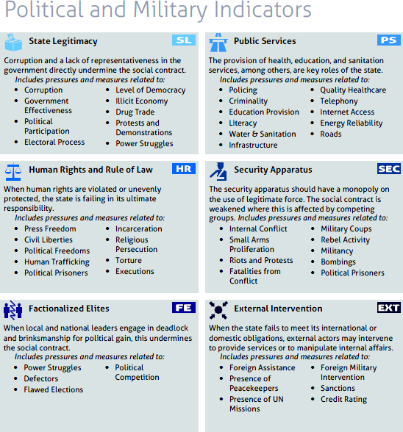

This is my first data work, just trying to explore the story from it.

First Top 15 failed state index 2013
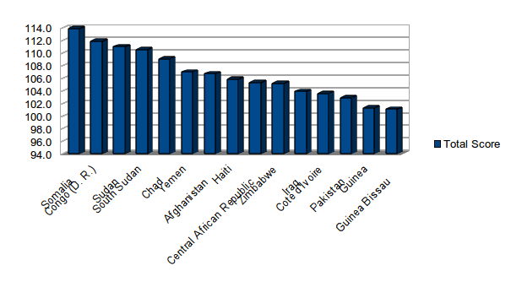
This is the alert region countries list which are in worst situations. In top 15, Somalia is in top position and Guinea Bissau is in 15th

Most Success Country on World

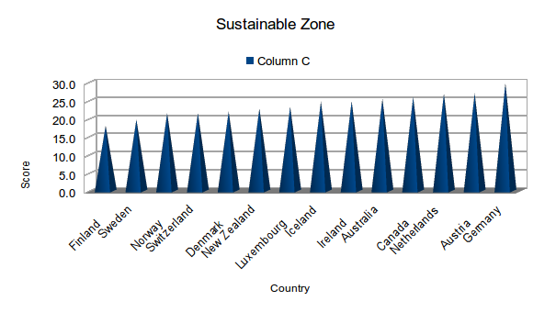
Least score country is most success country. From above figure, We can see Finland is least score country it scores 18.0 …..

What is the status of Nepal?

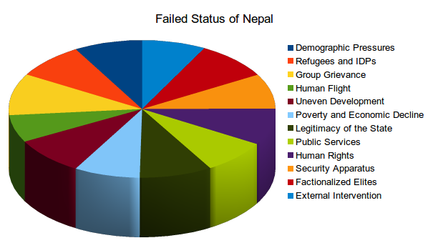
It shows social indication has great impact on nepal, above chart shows Group Grievance which include pressure and measures to Discrimination, Powerless, Ethnic Violence, Communal Violence and others.
South Asian Region
